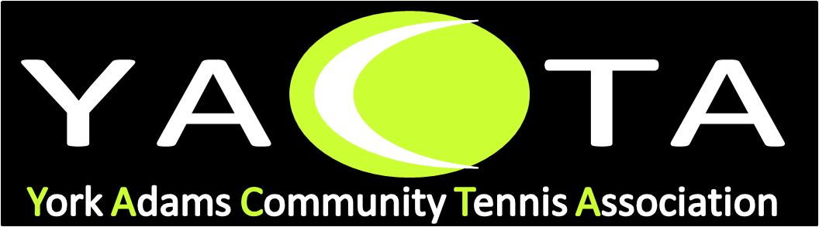
York – Adams18U/14U Stars Program
At YACTA Indoor Tennis Courts/SW Courts
Fall2019
Directed by Vicki Neudecker, DaveHeinzelmann
Dates: SundaysSept 15, 22, 29,Oct6, 13, 20 Time 1:00-2:30

Boys and girls, ages 10 through 18 who have serving and rallying skills. This program is to prepare players for varsity play.

Format: A competitive ladder includes instruction, fast paced drills, footwork, agility, conditioning, & match play structured for player’s ability of play. This program is to promote competitive tennis playing.

Cost: $84 once you are Junior Member of YACTA, register for this program by calling the YACTA Desk 717.797.5891 to register or pay by credit card. Make checks out to YACTA.

Email tennis55@comcast.net. Any questions call 717.965.9697.

Name__________________________ Email____________________________
Address_______________________________ City______________________
Zip Code __________ School _____________________________________
Phone Numbers_________________________________________________
Ability Level_____________ Amount Enclosed ____________ Age___________
I authorize the use of photographs and video photography of my son or daughter in electronic and print publications for the purpose of public relations, including promotional purpose usage. We will not receive any compensation for use of the photos. Media Release Signature _______________________________________

